**Step1**: connect all devices as per diagram and assign IP addresses as per table1.

Table1

|  |  |  |  |  |
| --- | --- | --- | --- | --- |
| **Device name** | **Interface** | **IP address** | **Subnet mask** | **Gateway** |
| Router1 | F0/0 | 172.100.100.1 | 255.255.0.0 |  |
| Router1 | F0/1 | 192.168.100.1 | 255.255.255.0 |  |
| Router2 | F0/0 | 172.100.100.2 | 255.255.0.0 |  |
| Router2 | F0/1 | 192.168.200.1 | 255.255.255.0 |  |
| PC1 |  | 192.168.100.2 | 255.255.255.0 | 192.168.100.1 |
| PC2 |  | 192.168.100.3 | 255.255.255.0 | 192.168.100.1 |
| PC3 |  | 192.168.200.2 | 255.255.255.0 | 192.168.200.1 |
| PC4 |  | 192.168.200.3 | 255.255.255.0 | 192.168.200.1 |

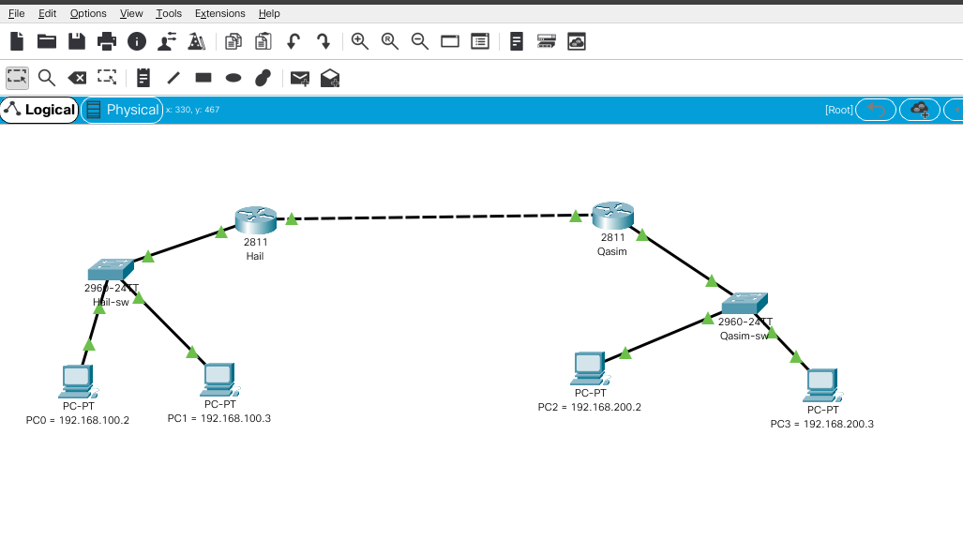

**Step2**: Change Router1 and LAN1 switch name as Hail and router2 and LAN2 as Qasim, and set enable encrypted password Cisco for All.

Command & Screenshot

|  |  |
| --- | --- |
| Hail | Qasim |
| Hail Router Config  Router> Enable  Router> Configure terminal    Router(config)> hostname Hail  Hail(config)> interface fastEthernet 0/0  Hail(config-if)> ip address 172.100.100.1 255.255.0.0  Hail(config-if)> no shutdown  Hail(config-if)> exit  Hail(config)> interface fastEthernet 0/0  Hail(config-if)> ip address 192.168.100.1 255.255.255.0  Hail(config-if)> no shutdown  Hail(config-if)> end  Hail# show ip route  Hail> Configure terminal  Hail(config)#ip route 192.168.200.0 255.255.255.0 fastEthernet 0/0  Hail(config)#end  Hail#write memory    for password :  Hail(config)#line console 0  Hail(config-line)#password Cisco  Hail(config-line)#login    switch Hail :  Switch>enable  Switch#configure terminal  Switch(config)#enable password Cisco  Switch(config)#exit | Qasim Router Config  Router> Enable  Router> Configure terminal    Router(config)> hostname Qasim  Qasim(config)> interface fastEthernet 0/0  Qasim(config-if)> ip address 172.100.100.2 255.255.0.0  Qasim(config-if)> no shutdown  Qasim(config-if)> exit  Qasim(config)> interface fastEthernet 0/0  Qasim(config-if)> ip address 192.168.200.1 255.255.255.0  Qasim(config-if)> no shutdown  Qasim(config-if)> end  Qasim# show ip route  Qasim> Configure terminal  Qasim(config)#ip route 192.168.100.0 255.255.255.0 172.100.100.1  Qasim(config)#end  Qasim#write memory    for password :  Qasim(config)#line console 0  Qasim(config-line)#password Cisco  Qasim(config-line)#login  switch Qasim :  Switch>enable  Switch#configure terminal  Switch(config)#enable password Cisco  Switch(config)#exit |

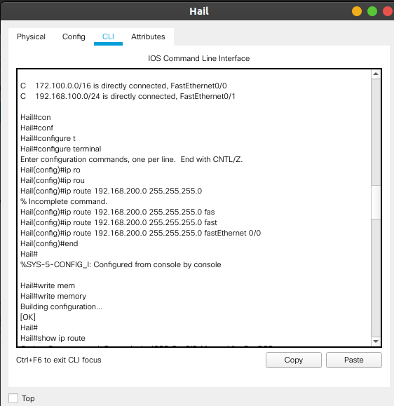

**Step3:** configure IP routing in router so that you can able to ping from One PC to other PC’s

Hail# show ip route

Hail> Configure terminal

Hail(config)#ip route 192.168.200.0 255.255.255.0 fastEthernet 0/0

Hail(config)#end

Hail#write memory

Qasim# show ip route

Qasim> Configure terminal

Qasim(config)#ip route 192.168.100.0 255.255.255.0 172.100.100.1

Qasim(config)#end

Qasim#write memory

Screenshot ping command :

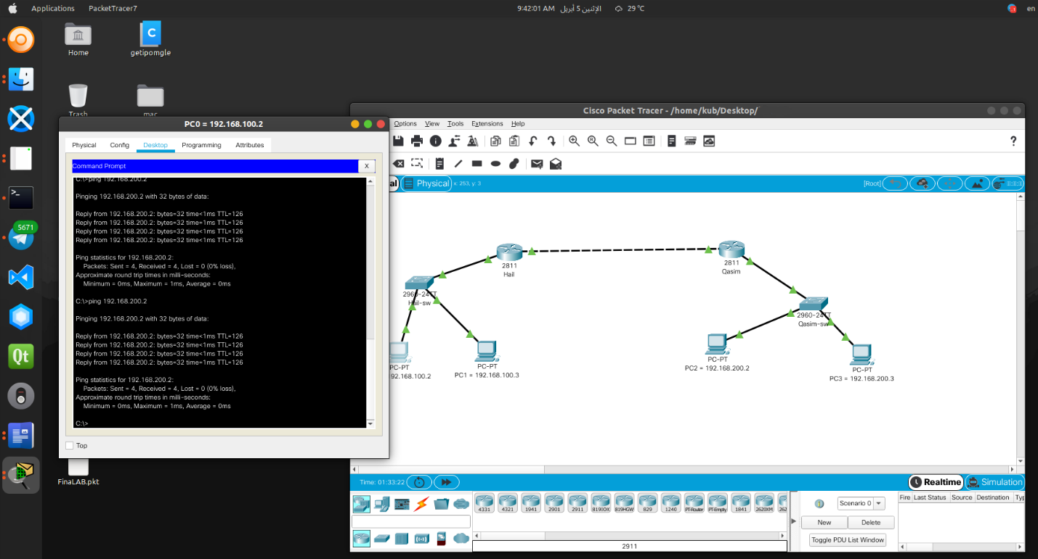

**Step4**: configure port security on Switch LAN1 port connected to PC1-192.168.100.2 so that only PC1 mac-address is allowed on this port, if other pc connect then port should go to Shutdown mode.

Switch>enable

Password: Cisco

Switch#configure terminal

Switch(config)#interface fastEthernet 0/2

Switch(config-if)#switchport mode access

Switch(config-if)#switchport port-security

Switch(config-if)#switchport port-security maximum 1

Switch(config-if)#switchport port-security violation protect

Switch(config-if)#switchport port-security mac-address sticky

Switch(config-if)#end

Switch#write memory

